M/V Lamorna wreck at Hordle Cliff, Milford-on Sea
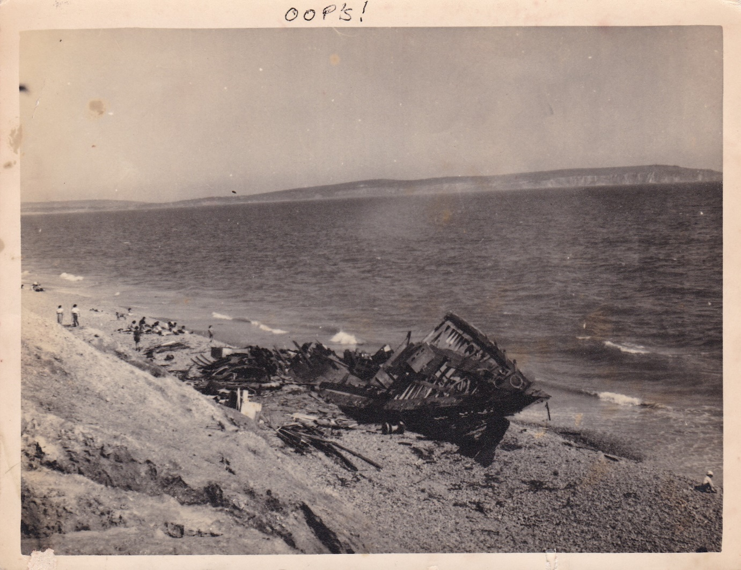
At 11.25 in the morning of the 4th November, 1951. The Niton Radio Station reported a wireless message from a steamer that a schooner was in distress sixteen and a half miles south-south-east Durleston Head, and at 11.40 the SWANAGE lifeboat R.I.P. was launched. A southerly gale was blowing, with a heavy sea. At 2.45 in the afternoon the lifeboat found H.M.S. Redpole towing the schooner Lamorna. of Southampton. The schooner had a crew of fourteen and was bound for the South China Sea to search for Captain Kidd’s treasure. The warship asked the life-boat to stand by, which she did, but at 4.20 the Redpole said the life-boat was no longer needed and she made for Poole, as in that weather she could not have been put into her house at SWANAGE. When she was about half a mile east of Poole harbour she received a wireless request from the Redpole, now four and a half miles south of the Needles, asking her to return and stand by again, but she replied that the Yarmouth life-boat could reach the position more quickly.
Accordingly at 6.10 a message was sent to the Yarmouth life-boat station through the Niton Radio Station and the Ventnor coastguard, and at 6.24 the life-boat S.O.E. left her moorings, with the second coxswain in command. She found that the Lamorna had broken away from the Redpole , had lost her masts and had damaged her rudder. The life-boat spread oil on the water to help calm the heavy, breaking seas, and with great difficulty. Owing to floating spars and ropes went alongside. She was slightly damaged, but she rescued the fourteen men and returned to her station, arriving at 8.50. The SWANAGE life-boat meanwhile had reached Poole at seven o’clock. The Lamorna eventually drifted ashore five miles east of Bournemouth. The owners and captain of the Lamorna gave 75 guineas to the Institution and 25 guineas to the Yarmouth crew in gratitude for the rescue- Rewards, Swanage, £83 3s 6d: Yarmouth, Isle of Wight, £9 3s 6d.
Quoted from Complete Historical Archives of the lifeboat Journal
Photo. courtesy of C.P. Quilter Milford-on- Sea Coast Guard.

