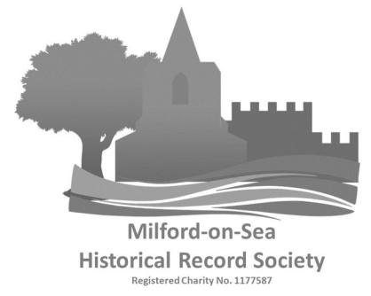
Outing to Hinton Ampner and Southwick Park Thursday July 7th, 2022
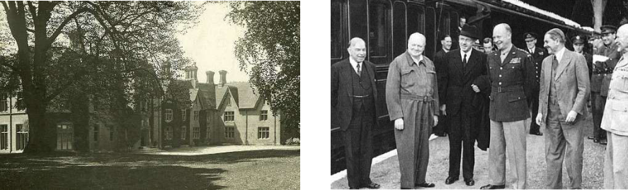

 |  | A
 |  | Ampner House | Churchill with Eisenhower
 | Itinerary
 | Leave Milford, Sea Road Car Park (53 seater bus) |  | 8:30am
 | Arrive Hinton Ampner |  | 10:00am
Entrance free for National Trust Members otherwise £10 (or £11 with Gift Aid).

There are toilet, café and picnic facilities on site, and you are free to explore the house and gardens.

Depart Hinton Ampner | 1:00pm prompt!
Arrive Southwick Park | 2:00pm
Lecture and Guided Tour of the D-Day map room.
Depart Southwick Park | 3:15pm
Arrive at The Golden Lion Pub* | 3:30pm
Tea, Coffee and light refreshments provided
Depart from Southwick | 4:30pm
Arrive back in Milford | 6:00pm
Price per person | £23.00
(Note: price excludes entrance fee for Ampner and lunch)

*This historic pub was used by Eisenhower, Montgomery et al as their unofficial officers’ mess!

Note: No food or drink to be consumed on the bus. Folding chairs, large bags etc… can be taken in the hold.

Booking Form for Ampner House and Southwick Park.

Thursday 7th July, 2022.

No. | Price Each Total (£)
MOSHRS Member Tickets | £23
Payment by Cheque (made payable to MOSHRS) attached

Online bank transfer to: HSBC Sort code 40-30-36 account 21214527

(To help identify your payment, please use your “surname – outing” as the reference.)

In all cases, please send this form to:
Membership Secretary, 31 Deans Court, Milford on Sea SO41 0SG or email: celiajones13@gmail.com

Full Names of Party*:

*Note that Southwick Park is an operational military police base and names must be supplied in advance for security.

Please address all outing queries to Vivien Robins (Telephone 01590 719824)

